**UNIT : IV**

Concept of modulation and their application.

[**Multiplexing**](https://www.geeksforgeeks.org/multiplexing-channel-sharing-in-computer-network/) is the sharing of a medium or bandwidth. It is the process in which multiple signals coming from multiple sources are combined and transmitted over a single communication/physical line.

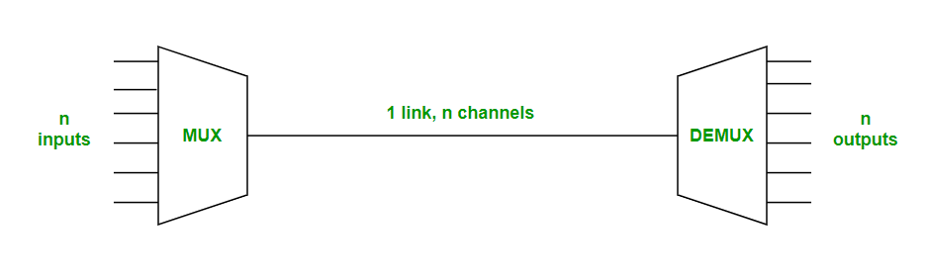

**Types of Multiplexing**  
There are two types of Multiplexing :

1. Frequency Division Multiplexing (FDM)
2. Time-Division Multiplexing (TDM)

**1. Frequency Division Multiplexing :**

Frequency division multiplexing is defined as a type of multiplexing where the bandwidth of a single physical medium is divided into a number of smaller, independent frequency channels.

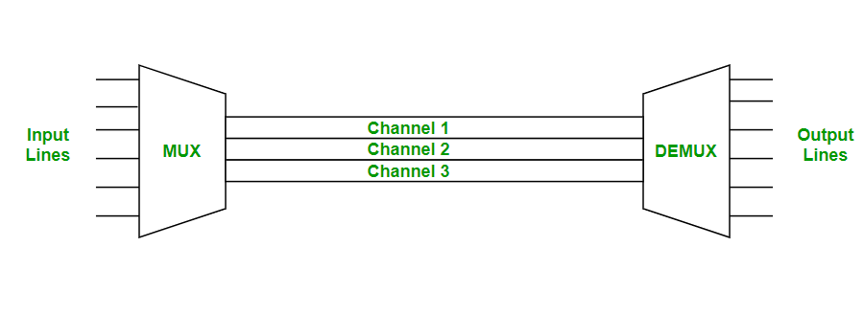

Frequency Division Multiplexing is used in radio and television transmission.

In FDM, we can observe a lot of inter-channel cross-talk, due to the fact that in this type of multiplexing the bandwidth is divided into frequency channels. In order to prevent the inter-channel cross talk, unused strips of bandwidth must be placed between each channel. These unused strips between each channel are known as guard bands.

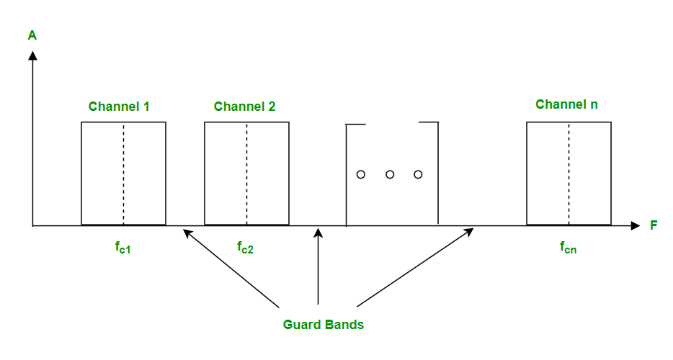

**2. Time Division Multiplexing :**

Time-division multiplexing is defined as a type of multiplexing wherein FDM, instead of sharing a portion of the bandwidth in the form of channels, in TDM, time is shared. Each connection occupies a portion of time in the link.

In Time Division Multiplexing, all signals operate with the same frequency (bandwidth) at different times.

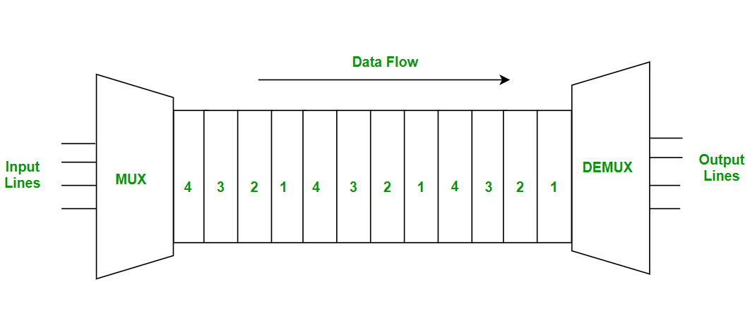

There are two types of Time Division Multiplexing :

1. Synchronous Time Division Multiplexing
2. Statistical (or Asynchronous) Time Division Multiplexing

**Synchronous TDM :**

Synchronous TDM is a type of Time Division Multiplexing where the input frame already has a slot in the output frame. Time slots are grouped into frames. One frame consists of one cycle of time slots.

Synchronous TDM is not efficient because if the input frame has no data to send, a slot remains empty in the output frame.

In synchronous TDM, we need to mention the synchronous bit at the beginning of each frame.

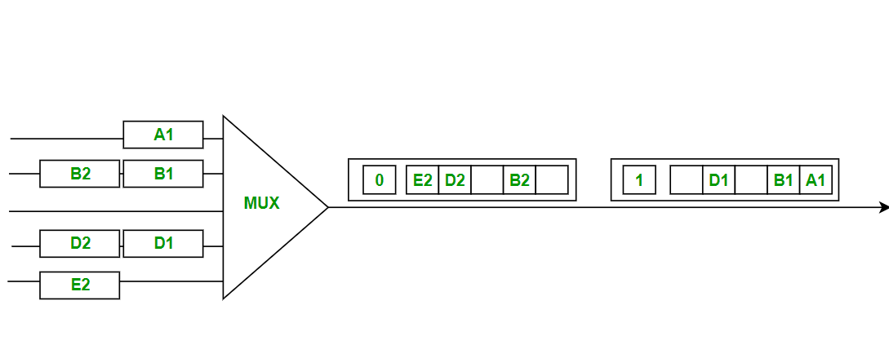

**Statistical TDM :**

Statistical TDM is a type of Time Division Multiplexing where the output frame collects data from the input frame till it is full, not leaving an empty slot like in Synchronous TDM.

In statistical TDM, we need to include the address of each particular data in the slot that is being sent to the output frame.

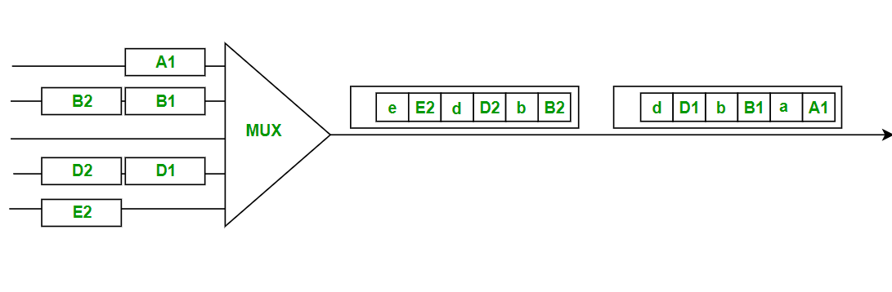

Statistical TDM is a more efficient type of time-division multiplexing as the channel capacity is fully utilized and improves the bandwidth efficiency.

**Switching techniques**

In large networks, there can be multiple paths from sender to receiver. The switching technique will decide the best route for data transmission.

Switching technique is used to connect the systems for making one-to-one communication.

**Classification Of Switching Techniques**

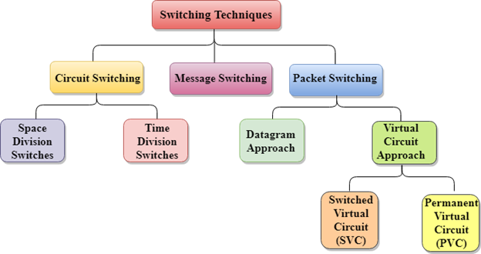

Circuit Switching

* Circuit switching is a switching technique that establishes a dedicated path between sender and receiver.
* In the Circuit Switching Technique, once the connection is established then the dedicated path will remain to exist until the connection is terminated.
* Circuit switching in a network operates in a similar way as the telephone works.
* A complete end-to-end path must exist before the communication takes place.
* In case of circuit switching technique, when any user wants to send the data, voice, video, a request signal is sent to the receiver then the receiver sends back the acknowledgment to ensure the availability of the dedicated path. After receiving the acknowledgment, dedicated path transfers the data.
* Circuit switching is used in public telephone network. It is used for voice transmission.
* Fixed data can be transferred at a time in circuit switching technology.

**Communication through circuit switching has 3 phases**x

* Circuit establishment
* Data transfer
* Circuit Disconnect

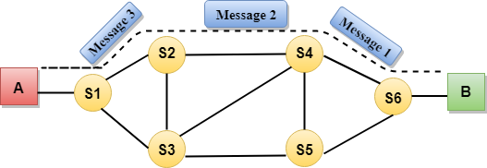

Circuit Switching can use either of the two technologies:

Space Division Switches:

* Space Division Switching is a circuit switching technology in which a single transmission path is accomplished in a switch by using a physically separate set of crosspoints.
* Space Division Switching can be achieved by using crossbar switch. A crossbar switch is a metallic crosspoint or semiconductor gate that can be enabled or disabled by a control unit.
* The Crossbar switch is made by using the semiconductor. For example, Xilinx crossbar switch using FPGAs.
* Space Division Switching has high speed, high capacity, and nonblocking switches.

**Space Division Switches can be categorized in two ways:**

* **Crossbar Switch**
* **Multistage Switch**

Crossbar Switch

The Crossbar switch is a switch that has n input lines and n output lines. The crossbar switch has n2 intersection points known as **crosspoints.**

**Disadvantage of Crossbar switch:**

The number of crosspoints increases as the number of stations is increased. Therefore, it becomes very expensive for a large switch. The solution to this is to use a multistage switch.

Multistage Switch

* Multistage Switch is made by splitting the crossbar switch into the smaller units and then interconnecting them.
* It reduces the number of crosspoints.
* If one path fails, then there will be an availability of another path.

**Advantages Of Circuit Switching:**

* In the case of Circuit Switching technique, the communication channel is dedicated.
* It has fixed bandwidth.

**Disadvantages Of Circuit Switching:**

* Once the dedicated path is established, the only delay occurs in the speed of data transmission.
* It takes a long time to establish a connection approx 10 seconds during which no data can be transmitted.
* It is more expensive than other switching techniques as a dedicated path is required for each connection.
* It is inefficient to use because once the path is established and no data is transferred, then the capacity of the path is wasted.
* In this case, the connection is dedicated therefore no other data can be transferred even if the channel is free.

Message Switching

* Message Switching is a switching technique in which a message is transferred as a complete unit and routed through intermediate nodes at which it is stored and forwarded.
* In Message Switching technique, there is no establishment of a dedicated path between the sender and receiver.
* The destination address is appended to the message. Message Switching provides a dynamic routing as the message is routed through the intermediate nodes based on the information available in the message.
* Message switches are programmed in such a way so that they can provide the most efficient routes.
* Each and every node stores the entire message and then forward it to the next node. This type of network is known as **store and forward network.**
* Message switching treats each message as an independent entity.

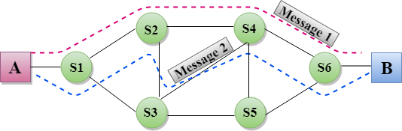

**Advantages Of Message Switching**

* Data channels are shared among the communicating devices that improve the efficiency of using available bandwidth.
* Traffic congestion can be reduced because the message is temporarily stored in the nodes.
* Message priority can be used to manage the network.
* The size of the message which is sent over the network can be varied. Therefore, it supports the data of unlimited size.

**Disadvantages Of Message Switching**

* The message switches must be equipped with sufficient storage to enable them to store the messages until the message is forwarded.
* The Long delay can occur due to the storing and forwarding facility provided by the message switching technique.

Packet Switching

* The packet switching is a switching technique in which the message is sent in one go, but it is divided into smaller pieces, and they are sent individually.
* The message splits into smaller pieces known as packets and packets are given a unique number to identify their order at the receiving end.
* Every packet contains some information in its headers such as source address, destination address and sequence number.
* Packets will travel across the network, taking the shortest path as possible.
* All the packets are reassembled at the receiving end in correct order.
* If any packet is missing or corrupted, then the message will be sent to resend the message.
* If the correct order of the packets is reached, then the acknowledgment message will be sent.

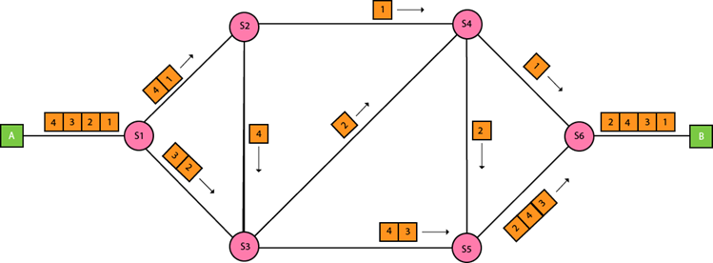

Approaches Of Packet Switching:

There are two approaches to Packet Switching:

Datagram Packet switching:

* It is a packet switching technology in which packet is known as a datagram, is considered as an independent entity. Each packet contains the information about the destination and switch uses this information to forward the packet to the correct destination.
* The packets are reassembled at the receiving end in correct order.
* In Datagram Packet Switching technique, the path is not fixed.
* Intermediate nodes take the routing decisions to forward the packets.
* Datagram Packet Switching is also known as connectionless switching.

Virtual Circuit Switching

* Virtual Circuit Switching is also known as connection-oriented switching.
* In the case of Virtual circuit switching, a preplanned route is established before the messages are sent.
* Call request and call accept packets are used to establish the connection between sender and receiver.
* In this case, the path is fixed for the duration of a logical connection.

**Let's understand the concept of virtual circuit switching through a diagram:**

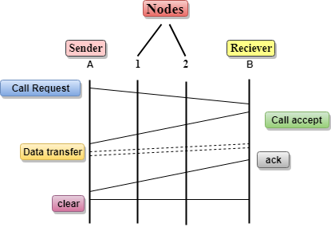

* In the above diagram, A and B are the sender and receiver respectively. 1 and 2 are the nodes.
* Call request and call accept packets are used to establish a connection between the sender and receiver.
* When a route is established, data will be transferred.
* After transmission of data, an acknowledgment signal is sent by the receiver that the message has been received.
* If the user wants to terminate the connection, a clear signal is sent for the termination.

**Transmission Modes :**

There are two methods used for transferring data between computers which are given below: Serial Transmission and Parallel Transmission.

**Serial Transmission:**   
In Serial Transmission, data-bit flows from one computer to another computer in bi-direction. In this transmission, one bit flows at one clock pulse. In Serial Transmission, 8 bits are transferred at a time having a start and stop bit.

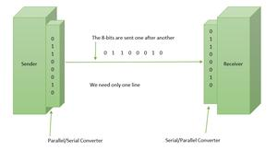

*Serial Transmission*

**Parallel Transmission:**   
In Parallel Transmission, many bits are flow together simultaneously from one computer to another computer. Parallel Transmission is faster than serial transmission to transmit the bits. Parallel transmission is used for short distance. 

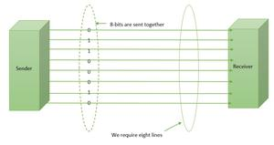

*Parallel Transmission*

**Difference between Serial and Parallel Transmission:**

| S.NO | Serial Transmission | Parallel Transmission |
| --- | --- | --- |
| 1. | In this type, a single communication link is used to transfer data from one end to another | In this type, multiple parallels links used to transmit the data |
| 2. | In serial transmission, data(bit) flows in bi-direction. | In Parallel Transmission, data flows in multiple lines. |
| 3. | Serial Transmission is cost-efficient. | Parallel Transmission is not cost-efficient. |
| 4. | In serial transmission, one bit transferred at one clock pulse. | In Parallel Transmission, eight bits transferred at one clock pulse. |
| 5. | Serial Transmission is slow in comparison of Parallel Transmission. | Parallel Transmission is fast in comparison of Serial Transmission. |
| 6. | Generally, Serial Transmission is used for long-distance. | Generally, Parallel Transmission is used for short distance. |
| 7. | The circuit used in Serial Transmission is simple. | The circuit used in Parallel Transmission is relatively complex. |
| 8. | Serial Transmission is full duplex as sender can send as well as receive the data | Parallel Transmission is half-duplex since the data is either send or receive |
| 9. | Converters are required in a serial transmission to convert the data between internal and parallel form | No converters are required in Parallel Transmission |
| 10. | Serial transmission is reliable and straightforward. | Parallel transmission is unreliable and complicated. |

# Synchronous and Asynchronous Transmission

[**Synchronous Transmission**](https://www.geeksforgeeks.org/computer-organization-synchronous-data-transfer/)**:** In Synchronous Transmission, data is sent in form of blocks or frames. This transmission is the full-duplex type. Between sender and receiver, synchronization is compulsory. In Synchronous transmission, There is no gap present between data. It is more efficient and more reliable than asynchronous transmission to transfer a large amount of data.

**Example:**

* Chat Rooms
* Telephonic Conversations
* Video Conferencing   
  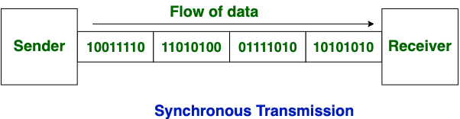

[**Asynchronous Transmission**](https://www.geeksforgeeks.org/asynchronous-serial-data-transfer/)**:** In Asynchronous Transmission, data is sent in form of byte or character. This transmission is the half-duplex type transmission. In this transmission start bits and stop bits are added with data. It does not require synchronization.

**Example:**

* Email
* Forums
* Letters  
  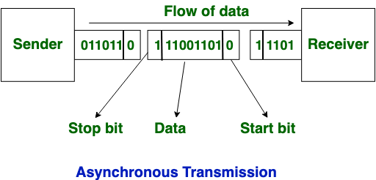

Now, let’s see the difference between Synchronous and Asynchronous Transmission:

| S. No. | Synchronous Transmission | Asynchronous Transmission |
| --- | --- | --- |
| 1. | In Synchronous transmission, data is sent in form of blocks or frames. | In Asynchronous transmission, data is sent in form of bytes or characters. |
| 2. | Synchronous transmission is fast. | Asynchronous transmission is slow. |
| 3. | Synchronous transmission is costly. | Asynchronous transmission is economical. |
| 4. | In Synchronous transmission, the time interval of transmission is constant. | In Asynchronous transmission, the time interval of transmission is not constant, it is random. |
| 5. | In this transmission, users have to wait till the transmission is complete before getting a response back from the server. | Here, users do not have to wait for the completion of transmission in order to get a response from the server. |
| 6. | In Synchronous transmission, there is no gap present between data. | In Asynchronous transmission, there is a gap present between data. |
| 7. | Efficient use of transmission lines is done in synchronous transmission. | While in Asynchronous transmission, the transmission line remains empty during a gap in character transmission. |
| 8. | The start and stop bits are not used in transmitting data. | The start and stop bits are used in transmitting data that imposes extra overhead. |
| 9. | Synchronous transmission needs precisely synchronized clocks for the information of new bytes. | Asynchronous transmission does not need synchronized clocks as parity bit is used in this transmission for information of new bytes. |

**UNIT : V**

Ethernet?

Ethernet is a type of communication protocol that is created at Xerox PARC in 1973 by Robert Metcalfe and others, which connects computers on a network over a wired connection. It is a widely used LAN protocol, which is also known as Alto Aloha Network. It connects computers within the local area network and wide area network. Numerous devices like printers and laptops can be connected by [LAN and WAN](https://www.javatpoint.com/lan-vs-wan)

within buildings, homes, and even small neighborhoods

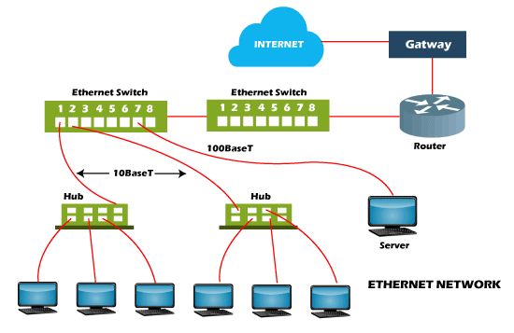

## **Different Types of Ethernet Networks**

An Ethernet device with CAT5/CAT6 copper cables is connected to a fiber optic cable through fiber optic media converters. The distance covered by the network is significantly increased by this extension for fiber optic cable. There are some kinds of Ethernet networks, which are discussed below:

* **Fast Ethernet:** This type of Ethernet is usually supported by a twisted pair or CAT5 cable, which has the potential to transfer or receive data at around100 Mbps. They function at 100Base and 10/100Base Ethernet on the fiber side of the link if any device such as a camera, laptop, or other is connected to a network. The fiber optic cable and twisted pair cable are used by fast Ethernet to create communication. The 100BASE-TX, 100BASE-FX, and 100BASE-T4 are the three categories of Fast Ethernet.
* **Gigabit Ethernet**: This type of Ethernet network is an upgrade from Fast Ethernet, which uses fiber optic cable and twisted pair cable to create communication. It can transfer data at a rate of 1000 Mbps or 1Gbps. In modern times, gigabit Ethernet is more common. This network type also uses CAT5e or other advanced cables, which can transfer data at a rate of 10 Gbps.

# Difference between Fast Ethernet and Gigabit Ethernet

| * S.NO | Fast Ethernet | Gigabit Ethernet |
| --- | --- | --- |
| 1. | Fast Ethernet provides 100 Mbps speed. | Gigabit Ethernet offers 1 Gbps speed. |
| 2. | Fast Ethernet is simple configured. | While Gigabit Ethernet is more complicated than Fast Ethernet. |
| 3. | Fast Ethernet generate more delay comparatively. | Gigabit Ethernet generates less delay than Fast Ethernet. |
| 4. | The coverage limit of Fast Ethernet is up to 10 km. | While the coverage limit of Gigabit Ethernet is up to 70 km. |
| 5. | The round-trip delay in Fast Ethernet is 100 to 500 bit times. | While the round-trip delay in Gigabit Ethernet is 4000 bit times. |
| 6. | Fast Ethernet is the Successor of 10-Base-T Ethernet. | While Gigabit Ethernet is the successor of Fast Ethernet. |
| 7. | Fast ethernet is less scalable than Gigabit ethernet. | Gigabit ethernet is more scalable than Fast ethernet. |

Let's take an example to understand the above terminology. The term **'100BaseT'** describes the following: -

**100**: - The number *100* indicates that the standard data transmission speed of this media type is 100Mbps.

**Base**: - The *'Base'* indicates that the media uses a baseband technology for transmission.

**T**: - The letter *'T'* indicates that the media uses twisted-pair cabling.

##### **Key points**

* The name of an Ethernet standard consists of three parts. The first part contains a number, the second part contains a word (mostly **Base**), and the third part contains a number or letters.
* The first part specifies the data transmission speed of the media.
* The second part indicates the technology or the method the media uses to transmit data. The word **'Base'** signifies a type of network that uses only one carrier frequency for signaling and requires all network stations to share its use.
* The third part specifics the length or type of the cable that the media uses in implementation. For example, if the standard contains a letter **T** in this part, it means the standard uses twisted-pair cabling. Or if a standard contains a number **5** in this part, it means the standard can span 500 meters long.

## **Properties and functions of the most common Ethernet standards**

The following section describes the properties and functions of the most command Ethernet standards.

### **10Base2**

This standard is also known as **ThinNet**. It uses coaxial cabling. It provides 10Mbps speed. It supports a maximum length of 200 meters. This standard is not used in modern networks.

### **10Base5**

This standard is also known as **ThickNet**. It also uses coaxial cabling and provides 10Mbps speed. It supports a maximum length of 500 meters. This standard is also not used in modern networks.

### **10BaseT**

10BaseT is one of the most common Ethernet standards used in Ethernet networks. It uses UTP (Cat3 or higher) cables and Hubs. Hubs use a physical star topology and a logical bus topology. Hubs repeat and forward signals to all nodes. Because of Hubs, the 10BaseT networks are slow and susceptible to collisions.

This standard also specifies a rule about how many Hubs you can use in a network. This rule specifies that a maximum of four hubs can be placed between communicating workstations. This rule ensures that all stations on the network can detect a collision.

Due to the slow data transmission speed and collision, modern networks do not use the 10BaseT standard.

### **10BaseF**

10BaseF is an implementation of 10BaseT over fiber optic cabling. 10BaseF offers only 10 Mbps, even though the fiber optic media has the capacity for much faster data rates. One of the implementations of 10BaseF is to connect two hubs as well as connecting hubs to workstations.

Due to the slow data transmission speed and expensive cabling, the 10BaseT standard is also not used in modern networks.

**Network Protocols :**

**1. TCP/IP(Transmission Control Protocol/ Internet Protocol):**These are a set of standard rules that allows different types of computers to communicate with each other. The IP protocol ensures that each computer that is connected to the Internet is having a specific serial number called the IP address. TCP specifies how data is exchanged over the internet and how it should be broken into IP packets. It also makes sure that the packets have information about the source of the message data, the destination of the message data, the sequence in which the message data should be re-assembled, and checks if the message has been sent correctly to the specific destination. The TCP is also known as a connection-oriented protocol.

The functionality of TCP/IP is divided into 4 layers with each one having specific protocols:

1. **Application Layer:**The application layer makes sure that the data from the sending end is received in a format that is acceptable and supported at the receiving end.
2. **Transport Layer:**The transport layer is responsible for the smooth transmission of data from one end to the other. It is also responsible for reliable connectivity, error recovery, and flow control of the data.
3. **Internet Layer:**This Internet Layer moves packets from source to destination by connecting independent networks.
4. **Network Access Layer:**The Network Access Layer sees how a computer connects to a network.

**SMTP(Simple Mail Transfer Protocol):**These protocols are important for sending and distributing outgoing emails. This protocol uses the header of the mail to get the email id of the receiver and enters the mail into the queue of outgoing mails. And as soon as, it delivers the mail to the receiving email id, it removes the email from the outgoing list. The message or the electronic mail may consider of text, video, image etc. It helps in setting up of some communication server rules.

**3. PPP(Point to Point Protocol):** It is a communication protocol that is used to create a direct connection between two communicating devices. This protocol defines the rules using which two devices will authenticate with each other and exchange information with each other. For example, A user connects his PC to the server of an Internet Service Provider also uses PPP. Similarly, for connecting two routers for direct communication it uses PPP.

**4. FTP (File Transfer Protocol):**This protocol is used for transferring files from one system to the other. This works on a client-server model. When a machine requests for file transfer from another machine, the FTO sets up a connection between the two and authenticates each other using their ID and Password. And, the desired file transfer takes place between the machines.

**5.** **SFTP(Secure File Transfer Protocol):**SFTP which is also known as SSH FTP refers to File Transfer Protocol (FTP) over Secure Shell (SSH) as it encrypts both commands and data while in transmission. SFTP acts as an extension to SSH and encrypts files and data then sends them over a secure shell data stream. This protocol is used to remotely connect to other systems while executing commands from the command line.

**HTTP(Hyper Text Transfer Protocol):**This protocol is used to transfer hypertexts over the internet and it is defined by the www(world wide web) for information transfer. This protocol defines how the information needs to be formatted and transmitted. And, it also defines the various actions the web browsers should take in response to the calls made to access a  particular web page. Whenever a user opens their web browser, the user will indirectly use HTTP as this is the protocol that is being used to share text, images, and other multimedia files on the World Wide Web.

# IP Address?

All the computers of the world on the Internet network communicate with each other with underground or underwater cables or wirelessly. If I want to download a file from the internet or load a web page or literally do anything related to the internet, my computer must have an address so that other computers can find and locate mine in order to deliver that particular file or webpage that I am requesting. In technical terms, that address is called **IP Address or Internet Protocol Address**.

Let us understand it with another example, like if someone wants to send you a mail then he/she must have your home address. Similarly, your computer too needs an address so that other computers on the internet can communicate with each other without the confusion of delivering information to someone else’s computer. And that is why each computer in this world has a unique IP Address. Or in other words, an IP address is a unique address that is used to identify computers or nodes on the internet. This address is just a string of numbers written in a certain format. It is generally expressed in a set of numbers for example 192.155.12.1. Here each number in the set is from 0 to 255 range. Or we can say that a full IP address ranges from 0.0.0.0 to 255.255.255.255. And these IP addresses are assigned by IANA(known as Internet Corporation For Internet Assigned Numbers Authority).

But what is Internet protocol? This is just a set of rules that makes the internet work. You are able to read this article because your computer or phone has a unique address where the page that you requested (to read this article from GeeksforGeeks) has been delivered successfully.

**Working of IP addresses**

The working of IP addresses is similar to other languages. It can also use some set of rules to send information. Using these protocols we can easily send, and receive data or files to the connected devices. There are several steps behind the scenes. Let us look at them

* Your device directly requests your Internet Service Provider which then grants your device access to the web.
* And an IP Address is assigned to your device from the given range available.
* Your internet activity goes through your service provider, and they route it back to you, using your IP address.
* Your IP address can change. For example, turning your router on or off can change your IP Address.
* When you are out from your home location your home IP address doesn’t accompany you. It changes as you change the network of your device.

### Types of IP Address

IP Address is of two types:

**1. IPv4:**Internet Protocol version 4. It consists of 4 numbers separated by the dots. Each number can be from 0-255 in decimal numbers. But computers do not understand decimal numbers, they instead change them to binary numbers which are only 0 and 1. Therefore, in binary, this (0-255) range can be written as (00000000 – 11111111). Since each number N can be represented by a group of 8-digit binary digits. So, a whole IPv4 binary address can be represented by 32-bits of binary digits. In IPv4, a unique sequence of bits is assigned to a computer, so a total of (2^32) devices approximately = 4,294,967,296 can be assigned with IPv4.

IPv4 can be written as:

*189.123.123.90*

*2011:0bd9:75c5:0000:0000:6b3e:0170:8394*

**2. IPv6:**But, there is a problem with the IPv4 address. With IPv4, we can connect only the above number of 4 billion devices uniquely, and apparently, there are much more devices in the world to be connected to the internet. So, gradually we are making our way to **IPv6 Address**which is a 128-bit IP address. In human-friendly form, IPv6 is written as a group of 8 hexadecimal numbers separated with colons(:). But in the computer-friendly form, it can be written as 128 bits of 0s and 1s. Since, a unique sequence of binary digits is given to computers, smartphones, and other devices to be connected to the internet. So, via IPv6 a total of (2^128) devices can be assigned with unique addresses which are actually more than enough for upcoming future generations.

IPv6 can be written as:

*2011:0bd9:75c5:0000:0000:6b3e:0170:8394*

# Sliding Window Protocol

Sliding window protocols are data link layer protocols for reliable and sequential delivery of data frames. The sliding window is also used in Transmission Control Protocol.

In this protocol, multiple frames can be sent by a sender at a time before receiving an acknowledgment from the receiver. The term sliding window refers to the imaginary boxes to hold frames. Sliding window method is also known as windowing.

## **Working Principle**

In these protocols, the sender has a buffer called the sending window and the receiver has buffer called the receiving window.

The size of the sending window determines the sequence number of the outbound frames. If the sequence number of the frames is an n-bit field, then the range of sequence numbers that can be assigned is 0 to 2𝑛−1. Consequently, the size of the sending window is 2𝑛−1. Thus in order to accommodate a sending window size of 2𝑛−1, a n-bit sequence number is chosen.

The sequence numbers are numbered as modulo-n. For example, if the sending window size is 4, then the sequence numbers will be 0, 1, 2, 3, 0, 1, 2, 3, 0, 1, and so on. The number of bits in the sequence number is 2 to generate the binary sequence 00, 01, 10, 11.

The size of the receiving window is the maximum number of frames that the receiver can accept at a time. It determines the maximum number of frames that the sender can send before receiving acknowledgment.

## **Example**

Suppose that we have sender window and receiver window each of size 4. So the sequence numbering of both the windows will be 0,1,2,3,0,1,2 and so on. The following diagram shows the positions of the windows after sending the frames and receiving acknowledgments.

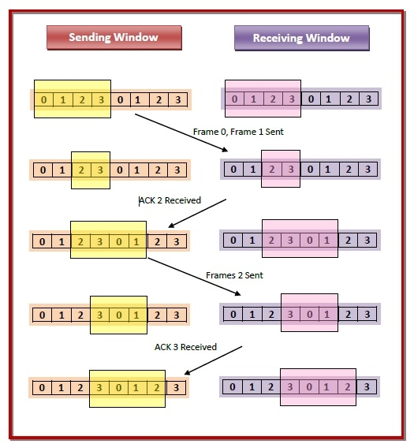

## **Types of Sliding Window Protocols**

The Sliding Window ARQ (Automatic Repeat reQuest) protocols are of two categories :

* **Go – Back – N ARQ**

Go – Back – N ARQ provides for sending multiple frames before receiving the acknowledgment for the first frame. It uses the concept of sliding window, and so is also called sliding window protocol. The frames are sequentially numbered and a finite number of frames are sent. If the acknowledgment of a frame is not received within the time period, all frames starting from that frame are retransmitted.

* **Selective Repeat ARQ**

This protocol also provides for sending multiple frames before receiving the acknowledgment for the first frame. However, here only the erroneous or lost frames are retransmitted, while the good frames are received and buffered.

# What is pipelining?

In computer networking, pipelining is the method of sending multiple data units without waiting for an acknowledgment for the first frame sent. Pipelining ensures better utilization of network resources and also increases the speed of delivery, particularly in situations where a large number of data units make up a message to be sent.

## **Flow Diagram of Pipelined Data Transmission**

The following flow diagram depicts data transmission in a pipelined system versus that in a non-pipelined system. Here, pipelining is incorporated in the data link layer, and four data link layer frames are sequentially transmitted.

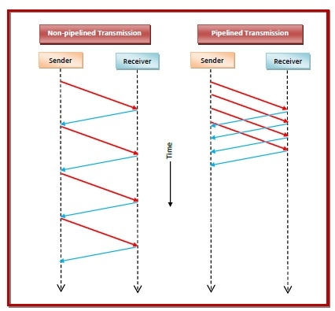

## **Data Link Protocols that uses Pipelining**

Two data link layer protocols use the concept of pipelining −

* **Go – Back – N**

Go – Back – N protocol provides for pipelining of frames, i.e. sending multiple frames before receiving the acknowledgment for the first frame. The frames are sequentially numbered and a finite number of frames are sent depending upon the size of the sending window. If the Non-pipelined Transmission Pipelined Transmission Sender Receiver Sender Receiver Time acknowledgment of a frame is not received within the time period, all frames starting from that frame are retransmitted. The size of the receiving window in 1 in this case.

* **Selective Repeat**

This protocol also incorporates the concept of pipelining. Here, the receiver window is of size greater than 1. In this protocol, only the erroneous or lost frames are retransmitted, while the good frames are received and buffered. When the sender times out, the oldest unacknowledged frame is retransmitted. If the retransmitted frame is received correctly, then the receiver delivers all the frames it has buffered starting with the retransmitted frame.

**UNIT : VI**

**Difference between Internet and Intranet**

Generally, most people are confused between the internet and the intranet. While there are exist lots of differences to differentiate them.

**Internet:**   
Internet is used to connect the different networks of computers simultaneously. It is a public network therefore anyone can access the internet. On the internet, there are multiple users and it provides an unlimited of information to the users.

**Intranet:**   
Intranet is the type of internet that is used privately. It is a private network therefore anyone can’t access the intranet. On the intranet, there is a limited number of users and it provides a piece of limited information to its users.

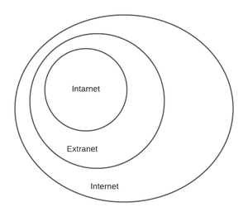

*Types of network*

Now, we shall see the difference between the internet and intranet:

|  |  |  |
| --- | --- | --- |
| S.NO | Internet | Intranet |
| 1. | Internet is used to connect different networks of computers simultaneously. | Intranet is owned by private firms. |
| 2. | On the internet, there are multiple users. | On an intranet, there are limited users. |
| 3. | Internet is unsafe. | Intranet is safe. |
| 4. | On the internet, there is more number of visitors. | In the intranet, there is less number of visitors. |
| 5. | Internet is a public network. | Intranet is a private network. |
| 6. | Anyone can access the Internet. | In this, anyone can’t access the Intranet. |
| 7. | The Internet provides unlimited information. | Intranet provides limited information. |
| 8. | Using Social media on your phone or researching resources via Google. | A company used to communicate internally with its employees and share information |

## **ISP: Internet Service Provider**

ISP stands for Internet Service Provider. It is a company that provides access to the internet and similar services such as Website designing and virtual hosting. For example, when you connect to the Internet, the connection between your Internet-enabled device and the internet is executed through a specific transmission technology that involves the transfer of information packets through an Internet Protocol route.

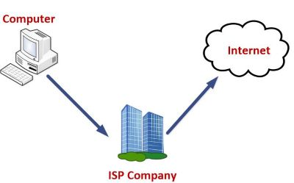

Data is transmitted through different technologies, including cable modem, dial-up, DSL, high speed interconnects. Accordingly, based on the method of data transmission, the Internet access provided by ISPs can be divided into many types, some of which are as follows:

**Dial-up Internet access:** It is the oldest technology to provide Internet access by modem to modem connection using telephone lines. In this method, the user's computer is connected to a modem with a telephone line. This method has become outdated today due to slow connection speed. However, in remote areas, this method can be used where the broadband network is not available.

**DSL:** DSL, which stands for 'digital subscriber line' is an advanced version of the dial-up Internet access method. It uses high frequency to execute a connection over the telephone network and allows the internet and the phone connection to run on the same telephone line. This method offers an Asymmetric Digital Subscriber (ADSL), where the upload speed is less than the download speed, and a Symmetric Digital Subscriber Line (SDSL), which offers equal upload and download speeds. Out of these two, ADSL is more popular among users and is popularly known as DSL.

**Wireless Broadband (WiBB):** It is a modern broadband technology for Internet access. It allows high-speed wireless internet within a large area. To use this technology, you are required to place a dish on the top of your house and point it to the transmitter of your Wireless Internet Service Provider (WISP).

**Wi-Fi Internet:** It is the short form for "wireless fidelity," which is a wireless networking technology that provides wireless high-speed Internet connections using radio waves. To use the internet, you are required to be within the range of wi-fi network. It is commonly used in public places such as hotels, airports, restaurants to provide internet access to customers.

**ISDN:** It is a short form of Integrated Services Digital Network. It is a telephone system network which integrates a high-quality digital transmission of voice and data over the same standard phone line. It offers a fast upstream and downstream Internet connection speed and allows both voice calls and data transfer.

**Ethernet:** It is a wired LAN (Local Area Network) where computers are connected within a primary physical space. It enables devices to communicate with each other via a protocol (a set of rules or common network language). It may provide different speeds such as 10 Mbps, 100 Mbps and 10 Gbps.

# Electronic Mail- Architecture and Services

**Electronic Mail** (e-mail) is one of most widely used services of [Internet](https://www.geeksforgeeks.org/the-internet-and-the-web/). This service allows an Internet user to send a **message in formatted manner (mail)** to the other Internet user in any part of world. Message in mail not only contain text, but it also contains images, audio and videos data. The person who is sending mail is called **sender** and person who receives mail is called**recipient**. It is just like postal mail service.

**Components of E-Mail System :** The basic components of an email system are : User Agent (UA), Message Transfer Agent (MTA), Mail Box, and Spool file. These are explained as following below.

1. **User Agent (UA) :** The UA is normally a program which is used to send and receive mail. Sometimes, it is called as mail reader. It accepts variety of commands for composing, receiving and replying to messages as well as for manipulation of the mailboxes.
2. **Message Transfer Agent (MTA) :** MTA is actually responsible for transfer of mail from one system to another. To send a mail, a system must have client MTA and system MTA. It transfer mail to mailboxes of recipients if they are connected in the same machine. It delivers mail to peer MTA if destination mailbox is in another machine. The delivery from one MTA to another MTA is done by [Simple Mail Transfer Protocol](https://www.geeksforgeeks.org/simple-mail-transfer-protocol-smtp/). 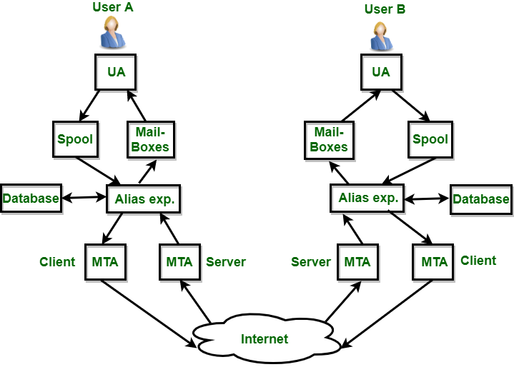
3. **Mailbox :** It is a file on local hard drive to collect mails. Delivered mails are present in this file. The user can read it delete it according to his/her requirement. To use e-mail system each user must have a mailbox . Access to mailbox is only to owner of mailbox.
4. **Spool file :** This file contains mails that are to be sent. User agent appends outgoing mails in this file using SMTP. MTA extracts pending mail from spool file for their delivery. E-mail allows one name, an **alias**, to represent several different e-mail addresses. It is known as **mailing list**, Whenever user have to sent a message, system checks recipient’s name against alias database. If mailing list is present for defined alias, separate messages, one for each entry in the list, must be prepared and handed to MTA. If for defined alias, there is no such mailing list is present, name itself becomes naming address and a single message is delivered to mail transfer entity.

**Services provided by E-mail system :**

* **Composition –** The composition refer to process that creates messages and answers. For composition any kind of text editor can be used.
* **Transfer –** Transfer means sending procedure of mail i.e. from the sender to recipient.
* **Reporting –** Reporting refers to confirmation for delivery of mail. It help user to check whether their mail is delivered, lost or rejected.
* **Displaying –** It refers to present mail in form that is understand by the user.
* **Disposition –** This step concern with recipient that what will recipient do after receiving mail i.e save mail, delete before reading or delete after reading.

# WWW-Client and Server model

* A client and server networking model is a model in which computers such as servers provide the network services to the other computers such as clients to perform a user based tasks. This model is known as client-server networking model.
* The application programs using the client-server model should follow the given below strategies:

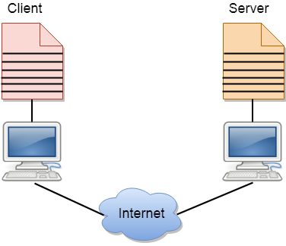

* An application program is known as a client program, running on the local machine that requests for a service from an application program known as a server program, running on the remote machine.
* A client program runs only when it requests for a service from the server while the server program runs all time as it does not know when its service is required.
* A server provides a service for many clients not just for a single client. Therefore, we can say that client-server follows the many-to-one relationship. Many clients can use the service of one server.
* Services are required frequently, and many users have a specific client-server application program. For example, the client-server application program allows the user to access the files, send e-mail, and so on. If the services are more customized, then we should have one generic application program that allows the user to access the services available on the remote computer.

## **Client**

A client is a program that runs on the local machine requesting service from the server. A client program is a finite program means that the service started by the user and terminates when the service is completed.

## **Server**

A server is a program that runs on the remote machine providing services to the clients. When the client requests for a service, then the server opens the door for the incoming requests, but it never initiates the service.

A server program is an infinite program means that when it starts, it runs infinitely unless the problem arises. The server waits for the incoming requests from the clients. When the request arrives at the server, then it responds to the request.

### **Advantages of Client-server networks:**

* **Centralized:** Centralized back-up is possible in client-server networks, i.e., all the data is stored in a server.
* **Security:** These networks are more secure as all the shared resources are centrally administered.
* **Performance:** The use of the dedicated server increases the speed of sharing resources. This increases the performance of the overall system.
* **Scalability:** We can increase the number of clients and servers separately, i.e., the new element can be added, or we can add a new node in a network at any time.

### **Disadvantages of Client-Server network:**

* **Traffic Congestion** is a big problem in Client/Server networks. When a large number of clients send requests to the same server may cause the problem of Traffic congestion.
* It does not have a robustness of a network, i.e., when the server is down, then the client requests cannot be met.
* A client/server network is very decisive. Sometimes, regular computer hardware does not serve a certain number of clients. In such situations, specific hardware is required at the server side to complete the work.
* Sometimes the resources exist in the server but may not exist in the client. For example, If the application is web, then we cannot take the print out directly on printers without taking out the print view window on the web.

## **Types of Servers**

The different types of servers are given below −

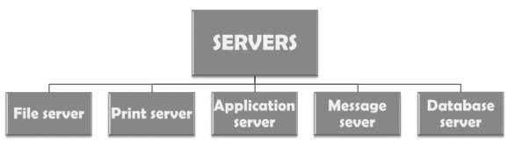

**File server** − These servers provide the services for storing, retrieving and moving the data. A user can read, write, exchange and manage the files with the help of file servers.

**Printer server** − The printer server is used for controlling and managing printing on the network. It also offers the fax service to the network users.

**Application server** − The expensive software and additional computing power can be shared by the computers in a network with the help of application servers.

**Message server** − It is used to co-ordinate the interaction between users, documents and applications. The data can be used in the form of audio, video, binary, text or graphics.

**Database server** − It is a type of application server.

**ISDN Protocol Architecture**

[Integrated Services Digital Network (ISDN)](https://www.geeksforgeeks.org/integrated-services-digital-network-isdn/) is simply considered as general-purpose digital network that is being capable of highly and fully supporting wide range of services like voice, data, text, and image with the help of very small set of standard multipurpose user-network interfaces. It is also useful in providing very useful framework for development and establishment of future telecommunications networks and services.

Previously, it is known as Integrated Digital Network (IDN) which is basically standardization digital technique for switching and transmission. ISDN also supports two types of switching operations i.e., circuit-switched operations and packet-switched operations. ISDN protocol architecture takes care of both of these switching operations. Circuit Switching is provided at the very nominal bit rate of 64 kbps whereas packet switching is provided for wide range of bit rates up to 64 kbps.

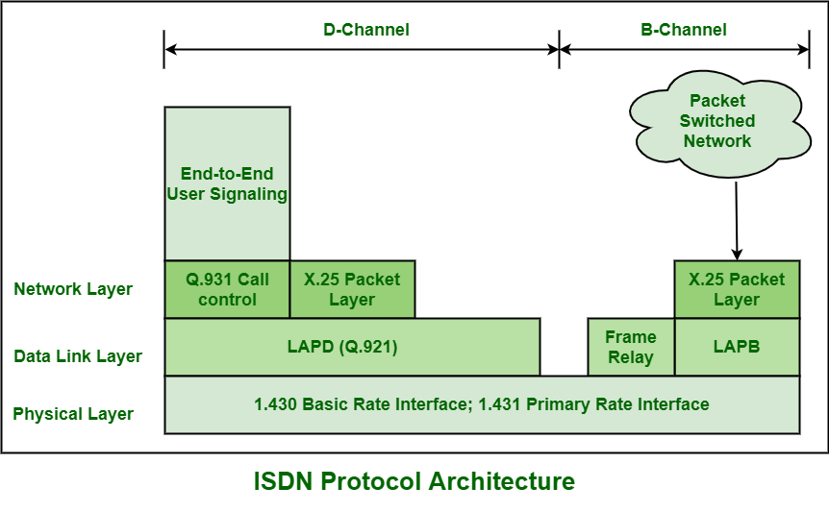

**Types of Channels :**  
ISDN generally contains three types of channels i.e., B-channel (Bearer channel), D-channel (Data Channel), and H-channel (Hybrid Channel).

1. **B-Channel :**  
   B-channel usually has 64 kbps data rate. This channel is required for voice, data, or other low data rate information. For higher data rates, two B-channel will get combined to give total of 128 kbps data rates.
2. **D-Channel :**  
   D-channel usually has 16 to 64 kbps data rate. This channel is required for signaling or packet-switched data. D-channel does not even carry data. It is simply required for carrying all of the controlling signals as establishing call, ringing, call interrupt, etc. It is common channel signaling that carries control signals for all of the using out-band signaling. Using this channel subscribes generally provide security to B connection. It is also required to carry data or information as videotext, tele-text, emergency services alarms, etc. in case of no signaling.
3. **H-Channel :**  
   H-channel generally has kbps, 1536 kbps, or 1920 kbps data rate. This channel is required for video, video-conferencing, high-speed data/audio, etc.

**Types of Layers :**  
ISDN usually contains two different layering mechanisms out of which one is for B/H Channels and other one for D Channel. For D-channel, ISDN contains three-layered protocol architecture. On the other hand, for B-channel, ISDN contains only one protocol layer i.e. physical layer and rest of upper layers are dependent on the application.

1. **Physical Layer :**  
   At this layer, B and D channels are same and uses either BRI or PRI Interface. It defines various primary aspects such as mechanical and electrical specifications of interface R, S, T, and U, Encoding, or power supply, etc. It is also based in X.21 for interfacing with public circuit switching network through an 8-pin connector.
2. **Data Link Layer :**  
   At this layer, B or D Channel generally uses LAPB or LAPD. B and D channels use different data link protocols i.e. LAPB For B channel and LAPD for D channel.
3. **Network Layer :**  
   At this channel, B-channel has different options in connecting to circuit either circuit-switched, packet-switched, frame relay, or ATM networks.

# FDDI

**FDDI** stands for **Fiber Distributed Data Interface**. It is a set of ANSI and ISO guidelines for information transmission on fiber-optic lines in Local Area Network (LAN) that can expand in run upto 200 km (124 miles). The FDDI convention is based on the **token ring protocol.**

In expansion to being expansive geographically, an FDDI neighborhood region arranges can support thousands of clients. FDDI is habitually utilized on the spine for a Wide Area Network(WAN).

An FDDI network contains **two token rings,**one for possible backup in case the essential ring falls flat.   
The primary ring offers up to 100 Mbps capacity. In case the secondary ring isn’t required for backup, it can also carry information, amplifying capacity to 200 Mbps. The single ring can amplify the most extreme remove; a double ring can expand 100 km (62 miles).

#### **Characteristics of FDDI**

* FDDI gives 100 Mbps of information throughput.
* FDDI incorporates two interfaces.
* It is utilized to associate the equipment to the ring over long distances.
* FDDI could be a LAN with Station Management.
* Allows all stations to have broken even with the sum of time to transmit information.
* FDDI defines two classes of traffic viz. synchronous and asynchronous.

#### **Advantages of FDDI**

* Fiber optic cables transmit signals over more noteworthy separations of approximately 200 km.
* It is conceivable to supply the need to the work stations associated within the chain. Consequently, based on the prerequisite a few stations are bypassed to supply speedier benefit to the rest.
* FDDI employments different tokens to make strides organize speed.
* It offers a higher transmission capacity (up to 250 Gbps). Thus, it can handle information rates up to 100 Mbps.
* It offers tall security because it is troublesome to spy on the fiber-optic link.
* Fiber optic cable does not break as effectively as other sorts of cables.

#### **Disadvantages of FDDI**

* FDDI is complex. Thus establishment and support require an incredible bargain of expertise.
* FDDI is expensive. Typically since fiber optic cable, connectors and concentrators are exceptionally costly.

**Private Branch Exchange (PBX)**

**Private Branch Exchange (PBX)** is private phone arrangement that permits clients to converse with one another. Diverse equipment parts cooperate to give availability to phone arrange. A PBX works as association’s inner phone arrangement. PBX system keeps up directing and propelled calling highlights for inbound and outbound calls.

Introducing PBX was and is quite difficult. An association helps at least one system administrators with many years of involvement with broadcast communications. You will likewise require physical space to put PBX system in workplace, for example, pantry or worker room. To all more likely value highlights and advantages of business-grade PBX, we should initially discuss telephone system.

A conventional phone system is just old phone system or POTS for short. It depends on curved pair wires from local telephone organization to structure. POTS is essential, dependable and has not changed much in 140 years. Phone organizations interface calls with others utilizing freely exchanged phone arrange (PTSN). PSTN makes it conceivable to fix calls locally to Verizon client AT&T client. Giving business telephone administration is no less. A basic business telephone bill can undoubtedly be in thousands to many lines every month. Hence, there must be superior way.

A PBX permits business to work interior telephone system and utilize fewer telephone lines from telephone organization. THE top PBX system offers alternative of overseeing voice messages, auto orderlies, and recorded messages. It incorporates telephone augmentations for everybody in organization. PBX has upgraded business calling process, which gives noteworthy update to past limitations. Before that, PBX was claimed and worked by troublesome individuals.

Today, PBX systems are essentially improved. Calls are currently made utilizing [Voice over Internet Protocol (VoIP)](https://www.geeksforgeeks.org/voice-over-internet-protocol-voip/) innovation, not at all like for local phone organization. Rather than simple lines, SIP gives availability to small amount of trunking cost. PBX system enables IT, pioneers, to deal with their current gadgets with all-advanced spine. By giving diverse business telephone numbers for various expansions. Then again, cloud consolidates PBX with expansion of telephone system that completely deals with best of two universes.

**Types of PBX Phone Systems :**  
There are various kinds of PBX phone frameworks that are reasonable for any business needs. As business applications move to cloud, have PBXs.

* **Hosted PBX –**   
  Manage every one of your workers’ phones from your internet browser. Buy administration and phone, plug them in and you are done. You have opportunity to modify PBX highlights, for example, call recording, call directing, auto orderly, music hold and call sending. Best of all, you can travel online for considerable length of time as opposed to weeks. Since you deal with this cloud-based PBX legitimately, every one of your gadgets is heavily influenced by you.
* **On-Campus PBX –**   
  For occasional upfront expenses with consulting charges, you can appreciate in vicinity PBX. This element is perfect in event that you do not have advancement plan, or are cost-precluded from exchanging. In any case, rather than full phone framework survey, you can update your PBX from IP-prepared to one.
* **PBX Sip Trunking –**   
  For individuals who have POX and need to exploit VoIP benefits, there is option for you. Taste Trunking gives voice administration to your organization PBX. This multi-channel voice administration is accessible without changing other PBX highlights. As your organization develops, include more channels.

**Advantages :**

* **Scalability –**   
  Since quantity of cell phones on your system is not constrained to specific pieces of more seasoned call exchanging gadgets, search for extra associations just to plug another telephone into your broadband association and boot. It interfaces with Internet by means of your PBX in cloud and can be completely initiated right away.
* **Flexibility –**   
  Not just is it simple to associate another telephone, however, you can likewise include another telephone anywhere and fundamentally interface with current phone organization. Since all administrations are worked through Internet, there are no limitations on topographical design of your framework. For instance, you may have client care working from base camp in Boston, far off branch workplaces in Florida, and San Francisco – and these areas work proficiently through solitary cloud PBX framework.
* **Mobility –**   
  Since worldwide business exercises have changed, individuals have voyaged great deal. This is to get call without objective of setting off to your office work area telephone when you are several miles away. Since call directing through administration is for you on Internet, they will naturally check rundown of telephone numbers you give online to expansions and proceed with chase until you make ground approach to your mobile phone.

**Disadvantages :**

* **Broadband required –**   
  Access to all cloud-put together administrations depends with respect to your capacity to get to Internet. Facilitated PBX is same. Notwithstanding, quality and dependability of your broadband circuit are significantly more significant when you intend to layer your organizations on voice traffic. The nature of administration equipment can be thought about, at end of day, dependability of association will decide nature of your involvement in voice administrations. Despite fact that it is conceivable to lay voice-over DSL and link modem circuits, we suggest broadband network with higher help level arrangements, for example, T1, Fiber, and Ethernet where accessible.
* **Current system constraints –**   
  This is anything but major inconvenience, however, can be costly relying upon your present system status. Since PBX is IP based, you need difficult information to organize. This implies base Category 5 change to deal with cabling and different telephones. In event that you need to isolate your voice and information traffic for quality, you additionally need switch equipped for parting these administrations. Likewise, on off chance that you do not as of now have this capacity, you can consider Power driving over Ethernet (PoE). In the event that this extra equipment is absent, it will be remembered for PBX arrangement.
* **More clients, higher MRC –**   
  For predetermined number of clients, PBX might be more affordable than base-based PBX. This level shifts from business to business. We found that organizations somewhere in range of two and twenty clients are commonly acceptable contenders to have PBX administrations, their correspondence needs, and what arrangement they right now have. As this sort of administration is paid for or added to every client seat, month to month repeating expense (MRC) increments with number of clients.

|  |  |  |
| --- | --- | --- |
|  |  |  |
|  |  |  |
|  |  |  |
|  |  |  |
|  |  |  |
|  |  |  |
|  |  |  |
|  |  |  |
|  |  |  |